**Annex F: Filling and Sealing the Pratt Pouch** with 2.2 ml of Nevirapine (NVP)

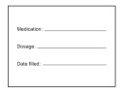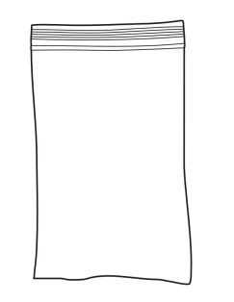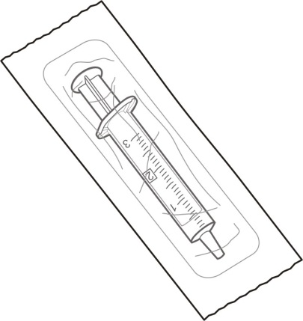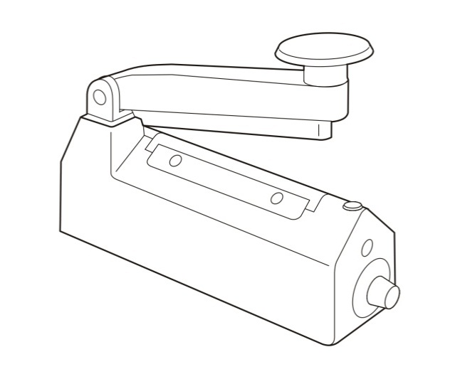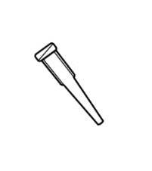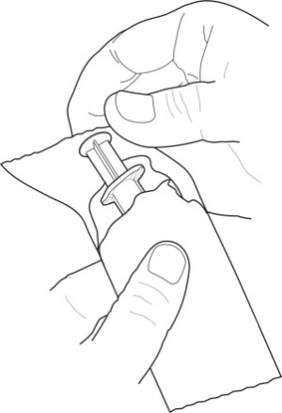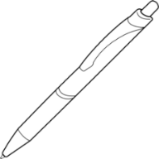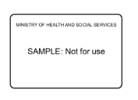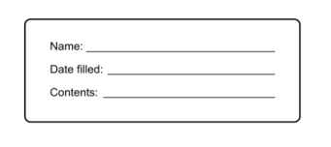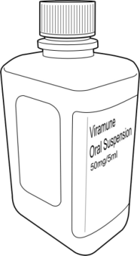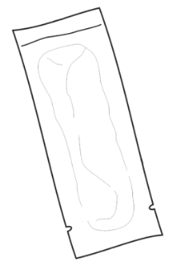**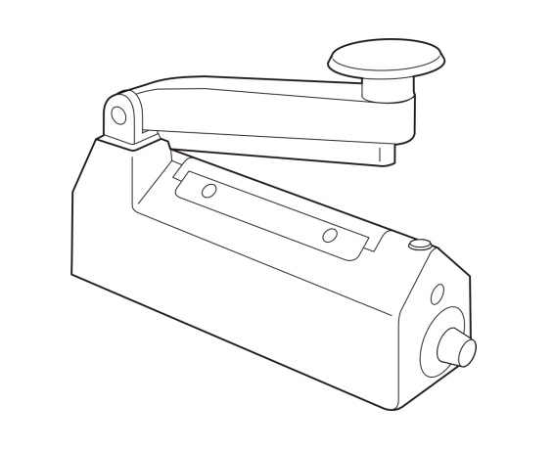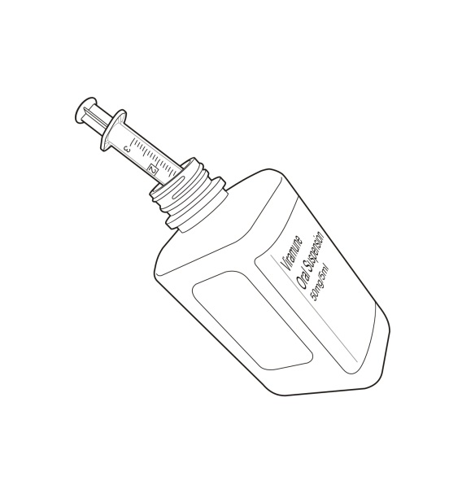[](https://portal.intrahealth.org/Departments/Communications/Image%20Library/IntraHealth%20logo/IntraHealth%20Logo%20for%20Documents%20in%20Word%20and%20PPT.jpg)**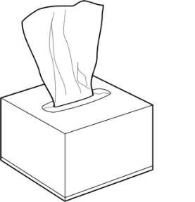

Fig. 1

Fig. 2

**2.1 Remove** syringe from packaging as shown (**Figure 1**).

**Plastic bags**

**Syringe**

Plunger

Barrel

Needle hub

Lip

**Syringe Tip**

**Mothers’ Instruction Sheet**

**Pharmacy Identification Card**

**Part 2**: Filling the Syringe

**2.2 Using** syringe without a tip, draw NVP from bottle into syringe (**Figure 2**).   
It may be necessary to tip the bottle.

**Note: Use only unopened medication bottles.**

**Pen**

**Preprinted / Handwritten labels**

**Nevirapine**

Opening

Tearing notches

**Pratt Pouch**

Handle

Heating element

Timer knob

Indicator  
light

**Heat Sealer**

**Tissues**

**Wash and dry hands well before starting process.**

**Part 1**: Assemble all Supplies

**2.3 Look** closely at the NVP in syringe to check for air bubbles. If bubbles are present, carefully expel medication back into bottle and fill syringe again.

Repeat until no air bubbles are seen in syringe.

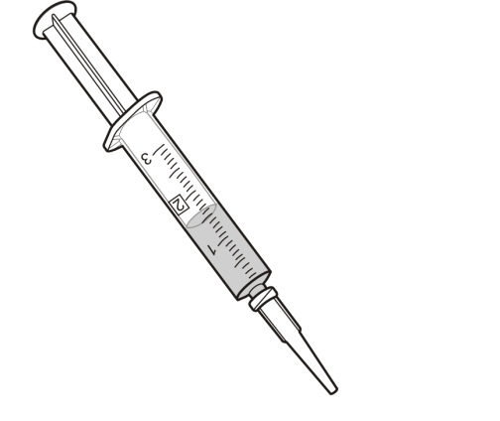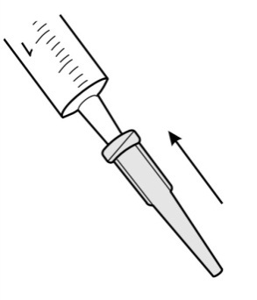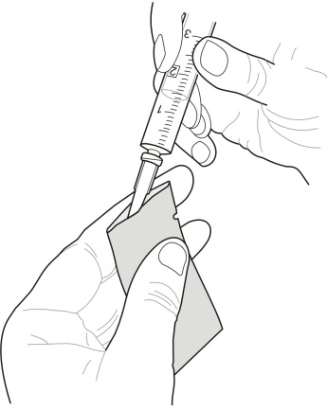

**2.7 Using** syringe with tip in place, draw NVP from bottle into syringe.   
Close NVP bottle after use (figure 4). **Note**: The usual infant dose of NVP is 2.0 ml. Filling pouch to 2.2 ml helps ensure the infant receives a full dose even though residual NVP will remain in pouch.

**Note**: Fill syringe carefully to ensure it contains the correct dose 2.2 ml. If too much NVP is placed in syringe, plunge the excess back into bottle.

Fig. 4

**3.2 Open** pouch by sliding syringe tip into open end (**Figure 5**).

**Note**: It may help to place an index finger along back of pouch opening   
to stabilize it.  
**Note**: Never touch inside of pouch with fingers, pencils, pens, screwdrivers   
or other objects as this can damage the pouch or contaminate the contents!

Fig. 5

Fig. 3

**2.5 Push** syringe tip onto needle hub of syringe (**Figure 3**).   
Ensure that the tip is secured tightly on the hub so that it will not loosen.

**2.6 Plunge** NVP from syringe back into bottle.

**Note**: steps 2.2—2.6 help ensure that the NVP remaining in needle tip does not contain air bubbles.

**2.8 With** a clean dry tissue, wipe excess NVP off syringe tip.  
**Note**: This is essential since any medication remaining on syringe tip can contaminate the top   
of the pouch during filling and then cause interference with the heat sealing process.

**2.4 With** a clean dry tissue, wipe excess NVP off needle hub.

**Part 3**: Filling the Pratt Pouch

**3.1 Fill** syringe with NVP according to instructions in Part 2- 2.2ml in fig (**Figure 4**).

**3.3 Gently** slide syringe all the way to bottom of pouch.

**3.4 Dispense** NVP into bottom of pouch by pushing plunger all the way down while slowly withdrawing syringe from pouch (this avoids getting medication on syringe tip).

**Note**: NVP should fill the bottom of pouch with little of the medication on the sides.

**3.5 Slowly** remove syringe from pouch. Avoid getting NVP on the sides of pouch.

**Note**: If small amount of NVP gets on outside of pouch, wipe it off completely and proceed with sealing.

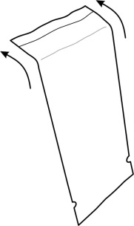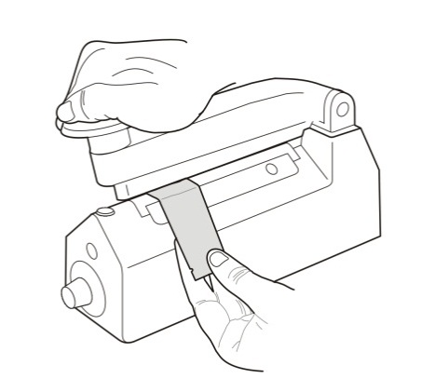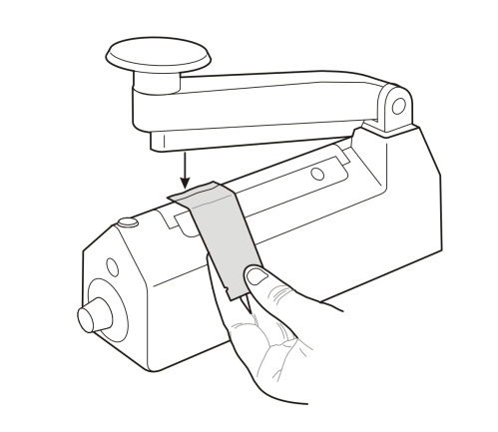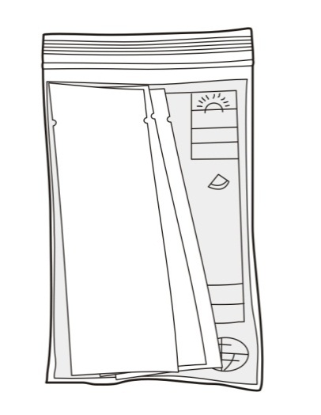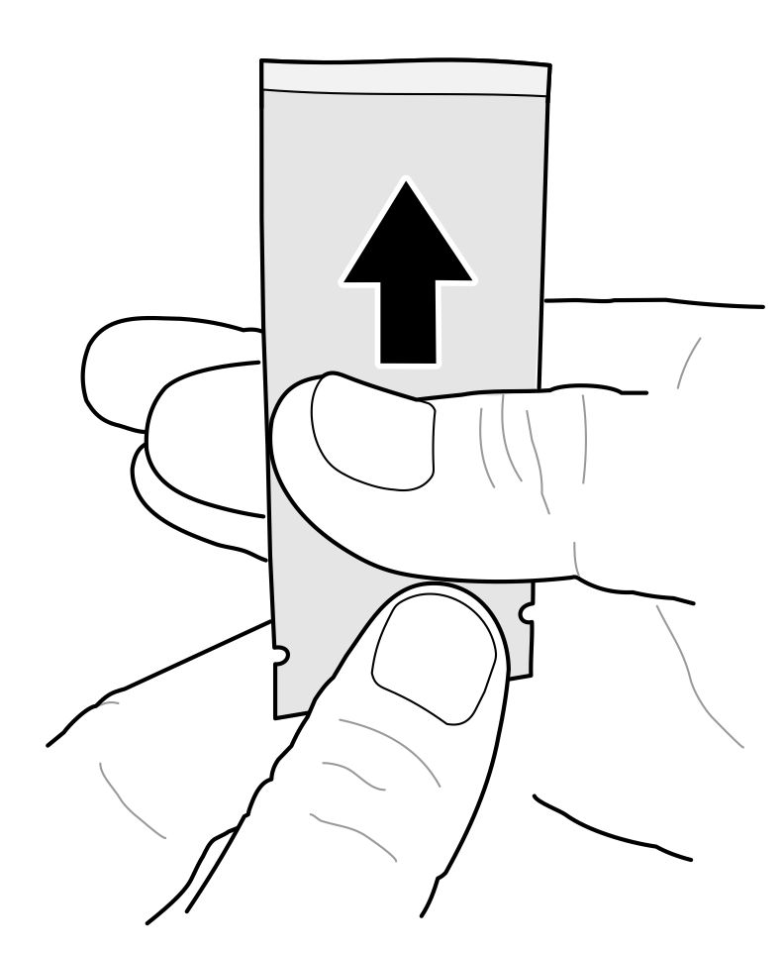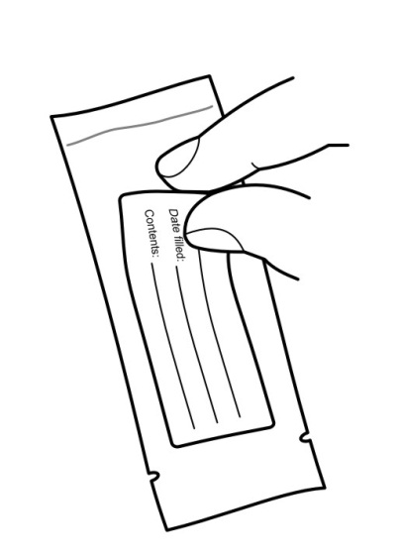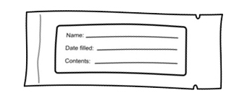

**4.3 Bend** open end of filled pouch to help close the opening (**Figure 6**).

Fig. 6

Fig. 8

**4.4 Place** pouch on heating element of sealer and hold in place as shown (**Figure 7**). Sealer should be touching pouch close to open end.

**4.5 Press** handle of sealer all the way down onto pouch and hold in place.

**Note**: Be sure to press handle all the way down onto heating element.   
Failure to do this may result in an inadequate seal, making pouch unusable!

**4.1 Fill** pouch with NVP according to instructions in Part 3.

**Part 4**: Sealing and Packaging the Pratt Pouch

**4.2 Plug** in heat sealer; turn timer knob to maximum setting.

**Note**: The sealer heats only when handle is depressed. Power to the heating element automatically turns off when operator’s hand is removed from handle or when required   
time has elapsed.

Fig. 7

**4.6 Hold** sealer handle down until red indicator light turns off and click is heard. This should take 1-3 seconds (**Figure 8**).

**Note**: Be sure that pouch remains on heating element for required amount of time! Early removal may result in inadequate seal, making pouch unusable!

**4.7 Remove** pouch from sealer.

Fig. 11

**4.11 Place filled, sealed and labeled pouches** in the pharmacy bags provided for this use (**Figure 11**). Also include the pharmacy identification card and the mothers’ instruction sheet (Annex M).

Fig. 10

**4.10 Affix** one label to each side of pouch, placing them below tearing notches so they do not interfere with opening pouch (**Figure 10**).

Fig. 9

**To fill additional pouches, repeat process starting with step 2.7 above.  
  
At the end of each pouch filling/sealing session, dispose of syringe and syringe tip. Use new supplies for subsequent sessions.  
  
Wash hands well when finished.  
  
Store filled pouches under conditions not exceeding 40°C.**

**4.9 Write** necessary information on large label according to local requirements.

**Note**: Do not write on pouch itself (empty or filled) or on label after it is placed on pouch as this can damage the foil and contaminate the contents.   
**Note**: The small label is preprinted; with drug name, dosage and expiration date; no additional written information is not necessary.

**Note**: The medication in the pouch is stable for one (1) year following sealing. The expiration date on the pouches is determined by the expiration date of the original medication bottle.

**4.8 Test** seal by sliding thumb and forefinger firmly up the pouch toward sealed end. If any medication oozes out from pouch, the seal was not sufficient and pouch should be discarded (**Figure 9**).

**Note**: Test the seal on every pouch in this way.